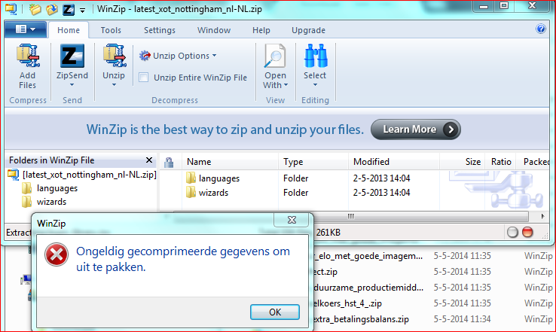

Als ik mer info opvraag, krijg ik de volgende informatie:
Extracting to "C:\xampp\htdocs\xertetoolkits\"
Use Path: yes Overlay Files: no
Extracting wizards\nl-NL\data.xwd
Extracting languages\nl-NL\website_code\php\workspaceproperties\usage_templates_template.inc
Extracting languages\nl-NL\website_code\php\workspaceproperties\shared_templates_template.inc
Extracting languages\nl-NL\website_code\php\workspaceproperties\workspace_library.inc
Extracting languages\nl-NL\website_code\php\workspaceproperties\peer_templates_template.inc
Extracting languages\nl-NL\website_code\php\workspaceproperties\rss_templates_template.inc
Extracting languages\nl-NL\website_code\php\workspaceproperties\syndication_templates_template.inc
Extracting languages\nl-NL\website_code\php\login_library.inc
Invalid compressed data to extract.
Extracting languages\nl-NL\website_code\php\display_library.inc
Extracting languages\nl-NL\website_code\php\workspaceproperties\xml_templates_template.inc
Extracting languages\nl-NL\website_code\php\workspaceproperties\folder_rss_templates_template.inc
Extracting languages\nl-NL\website_code\php\workspaceproperties\my_properties_template.inc
Extracting languages\nl-NL\website_code\php\management\play_security_management.inc
Extracting languages\nl-NL\website_code\php\management\users.inc
Extracting languages\nl-NL\website_code\php\management\templates.inc
Extracting languages\nl-NL\website_code\php\management\user_details_management.inc
Extracting languages\nl-NL\website_code\php\management\site.inc
Extracting languages\nl-NL\website_code\php\management\error_list.inc
Extracting languages\nl-NL\website_code\php\management\delete_template.inc
Extracting languages\nl-NL\website_code\php\management\site_details_management.inc
Extracting languages\nl-NL\website_code\php\properties\media_and_quota_template.inc
Extracting languages\nl-NL\website_code\php\properties\share_this_template.inc
Extracting languages\nl-NL\website_code\php\folderproperties\rename_folder_template.inc
Extracting languages\nl-NL\website_code\php\folderproperties\folder_rss_template.inc
Extracting languages\nl-NL\website_code\php\folderproperties\folderproperties_template.inc
Extracting languages\nl-NL\website_code\php\folderproperties\folder_content_template.inc
Extracting languages\nl-NL\website_code\php\import\import_template.inc
Extracting languages\nl-NL\website_code\php\peer\peer_review.inc
Extracting languages\nl-NL\website_code\php\import\fileupload.inc
Extracting languages\nl-NL\website_code\php\import\import.inc
Extracting languages\nl-NL\website_code\php\versioncontrol\template_close.inc
Extracting languages\nl-NL\website_code\php\versioncontrol\update_file.inc
Extracting languages\nl-NL\website_code\php\properties\name_select_gift_template.inc
Extracting languages\nl-NL\website_code\php\properties\gift_template.inc
Extracting languages\nl-NL\website_code\php\properties\properties_library.inc
Extracting languages\nl-NL\website_code\php\properties\sharing_status_template.inc
Extracting languages\nl-NL\website_code\php\properties\gift_this_template.inc
Extracting languages\nl-NL\website_code\php\properties\publish.inc
Extracting languages\nl-NL\website_code\php\properties\export_template.inc
Extracting languages\nl-NL\website_code\php\properties\name_select_template.inc
Extracting languages\nl-NL\website_code\php\management\user_templates.inc
Extracting languages\nl-NL\website_code\php\management\sync.inc
Extracting languages\nl-NL\feedback\index.inc
Extracting languages\nl-NL\properties.inc
Extracting languages\nl-NL\modules\site\module_functions.inc
Extracting languages\nl-NL\syndicate.inc
Extracting languages\nl-NL\play.inc
Extracting languages\nl-NL\folderproperties.inc
Extracting languages\nl-NL\index.inc
Extracting languages\nl-NL\management.inc
Extracting languages\nl-NL\modules\site\preview.inc
Extracting languages\nl-NL\modules\site\peer.inc
Extracting languages\nl-NL\modules\xerte\edit.inc
Extracting languages\nl-NL\modules\xerte\export_page.inc
Extracting languages\nl-NL\getfile.inc
Extracting languages\nl-NL\modules\xerte\peer.inc
Extracting languages\nl-NL\modules\xerte\preview.inc
Extracting languages\nl-NL\modules\site\edit.inc
Extracting languages\nl-NL\modules\site\export_page.inc
Extracting languages\nl-NL\modules\xerte\module_functions.inc
Extracting languages\nl-NL\peer.inc
Extracting languages\nl-NL\publishproperties.inc
Extracting languages\nl-NL\website_code\php\language_library.inc
Extracting languages\nl-NL\website_code\php\templates\delete_template.inc
Extracting languages\nl-NL\website_code\php\templates\remove_template.inc
Extracting languages\nl-NL\website_code\php\language\delete_language.inc
Extracting languages\nl-NL\website_code\php\language\import_language.inc
Extracting languages\nl-NL\website_code\php\management\template_details_management.inc
Extracting languages\nl-NL\website_code\php\management\management_library.inc
Extracting languages\nl-NL\website_code\php\database_library.inc
Extracting languages\nl-NL\website_code\php\templates\duplicate_template.inc
Extracting languages\nl-NL\website_code\php\folder_library.inc
Extracting languages\nl-NL\library\Xerte\Authentication\Db\deluser.inc
Extracting languages\nl-NL\library\Xerte\Authentication\Db\adduser.inc
Extracting languages\nl-NL\rss.inc
Extracting languages\nl-NL\library\Xerte\Authentication\Db\changepassword.inc
Extracting languages\nl-NL\library\Xerte\Authentication\Db.inc
Extracting languages\nl-NL\website_code\php\publish\publish_template.inc
Extracting languages\nl-NL\preview.inc
Extracting languages\nl-NL\data.inc
Extracting languages\nl-NL\workspaceproperties.inc
Extracting languages\nl-NL\website_code\scripts\properties_tab.js
Extracting languages\nl-NL\website_code\scripts\template_management.js
Extracting languages\nl-NL\website_code\scripts\management.js
Extracting languages\nl-NL\website_code\scripts\ajax_management.js
Extracting languages\nl-NL\website_code\scripts\logout.js
Extracting languages\nl-NL\website_code\scripts\import.js
Extracting languages\nl-NL\website_code\scripts\file_system.js
Extracting languages\nl-NL\library\Xerte\Authentication\Db.js
Extracting languages\nl-NL\modules\xerte\scorm2004.3rd\xttracking_scorm2004.3rd.js
Extracting languages\nl-NL\website_code\scripts\folderproperties_tab.js
Extracting languages\nl-NL\website_code\scripts\workspaceproperties_tab.js
Extracting languages\nl-NL\website_code\scripts\folders.js
Extracting languages\nl-NL\modules\xerte\scorm1.2\xttracking_scorm1.2.js
Extracting languages\engine_en-GB.xml
Extracting languages\engine_fr-FR.xml
Extracting languages\wizard_nl-BE.xml
Extracting languages\engine_nl-NL.xml
Extracting languages\engine_en-US.xml
Extracting languages\wizard_nl-NL.xml
Extracting languages\wizard_en-GB.xml
Extracting languages\language-config.xml
Extracting languages\engine_nl-BE.xml
Extracting languages\engine_es-ES.xml
Severe Error: Compressed data is invalid.

