If you're at a navigation tab and you pit a text as title and you are not using few spaces before the text, the arrow is coming through the first letter of the text.

Without spaces:
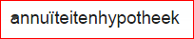
With spaces:
