Picture in new editor:
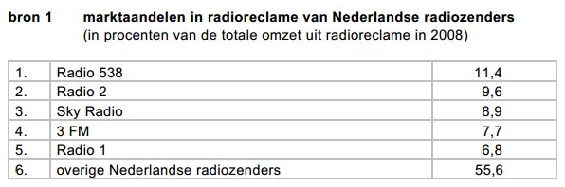
http://privatebeta.xerte.org.uk/USER-FILES/61-Loe-Nottingham/media/bron1.JPG
-------------------------------------------------------------------------------------------------------------------------------------
Picture playing the object:
http://privatebeta.xerte.org.uk/FileLocation%20+%20'media/bron1.JPG'

