Variables.
Using the Xerte in Dutch, I can’t make a table with variabes. I have tos o in English.
Going back to Dutch I get an error, and after that I don’t see or can use the table. But the table made in the English gersion wokres fine in the pages.
Why the problem in the Dutch language.
Xerte in Dutch.
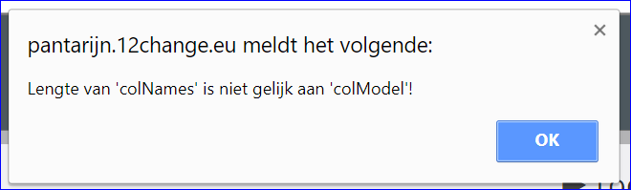
Length of 'colNames' is not equal to 'colModel'!
and
and running the LO in Xerte
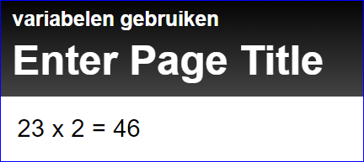
Xerte in English.
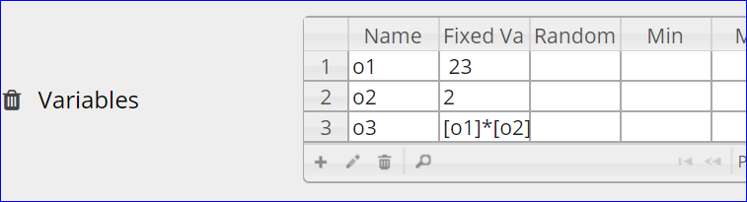
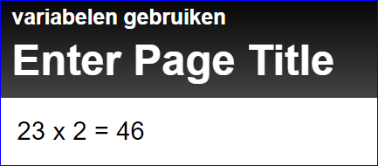
I can see and use the table
Online it workes fine.

