After unpacking the new release, my USER-FILES is still filled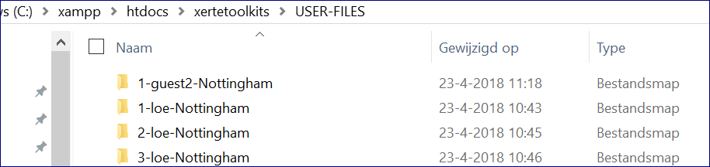
But when I start Xerte, there are no learning objects in Xerte. What do I have to do to be able to use
it again?
