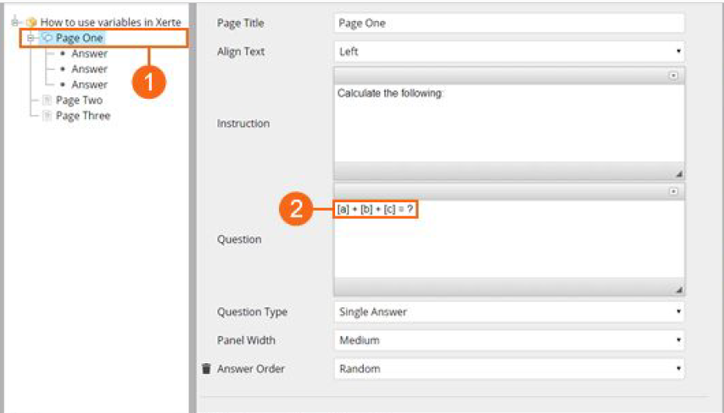
When using variables in a MCQ, what is entered into the answer field and selected in the ‘correct’ field? Is additional code required?
