Screenshot 1:

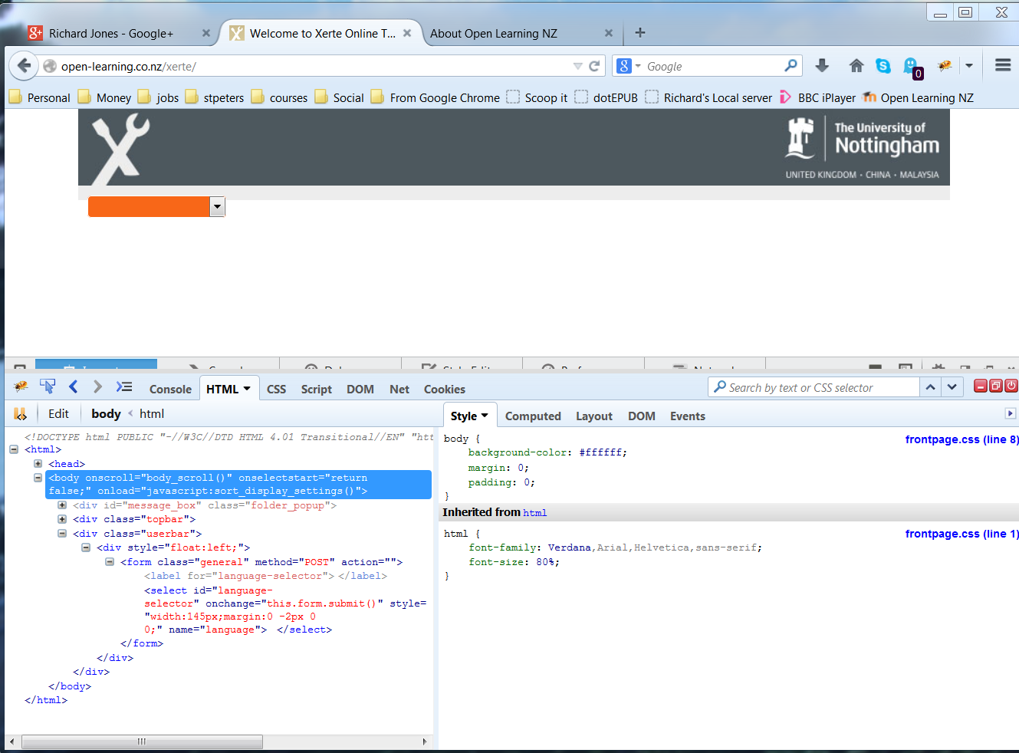

You can see nothing is generated after the language selector form is added.

Screenshot 2 (immediately after httpd restart):

